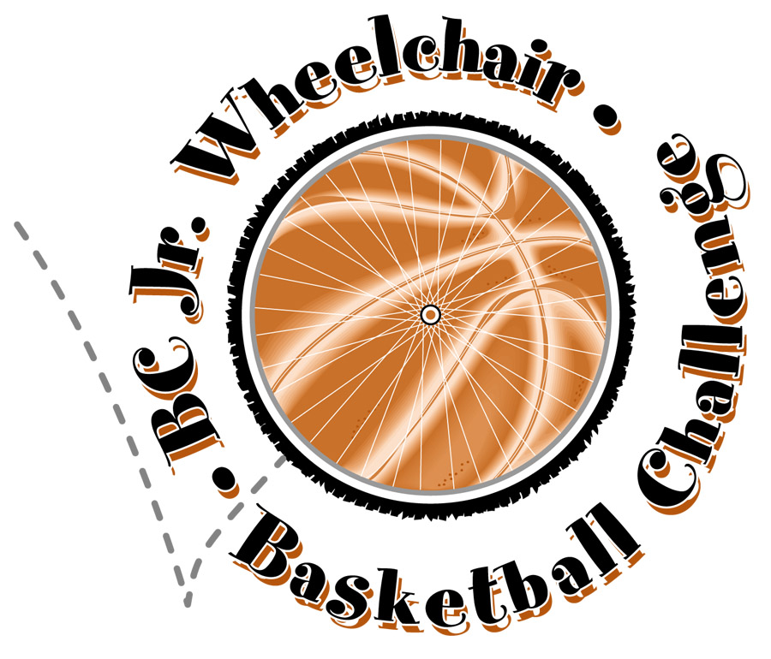
2012 BC Junior Challenge
Wheelchair Basketball Festival
You are invited to participate in the 13th Annual Junior Challenge Wheelchair Basketball Festival, hosted by the BC Wheelchair Basketball Society! All wheelchair basketball players between 8-24 years old (with some exceptions) are welcome! We are introducing 3 on 3 format so you’ll get more games and more touches to develop your skills and game!
Date: | November 10/11, 2012 (Saturday/Sunday)
Location: | McRoberts Secondary School – 8980 Williams Rd., Richmond, BC
Divisions: | Three divisions  1) 3 on 3 Mini Basket (8 ½ ft. hoop, appx. 8-13 yrs old),  2) 3 on 3 10 Ft. Hoop Challenge (appx. 12-18 yrs old), and  3) 3 on 3 10Ft. Hoop Performance (appx. 16-24 yrs old),  will be held, PENDING number of registrants. The division that you will be playing in will be determined by the coaches. However, please indicate your preference on your registration form.
Classification: | 1) Mini-Basket - Everyone gets close to equal floor time  2) 10ft Hoop Challenge - Everyone gets close to equal floor time.  3) 10ft. Hoop Performance - 9 pt. IWBF classification system where possible
Schedule: | A game schedule will be determined once all registrations have been received – but plan on being at the gymnasium most of Saturday and Sunday with awards taking place on Sunday afternoon.
Hotel  Information: | Holiday Inn Express  9351 Bridgeport Rd. Richmond BC V6X 1S3  2 Queen Beds or 1 King Bed WC Accessible (3 rooms available)  Rate: $89.00 Cdn. per night + 14.24% tax (based on 1-2 occupancy. $10 for each additional adult. No additional fee for children under 19. incl. breakfast/parking)  Hotel rooms must be booked by October 25, 2012  Reservations: 1-604-273-8080 or (Toll Free)1-877-273-8080  Online Booking: http://www.holidayinnexpressvancouverairport.com/  Mention booking code: BC Wheelchair Basketball Society
Registration  Information: | Registration Fee:  Early Bird Rate: $20.00/person with payment received by October 26th  Regular Rate: $30.00/person with payment received after October 26th  You may register as a team or an individual and you will be placed on a team.  * If you are BC residence and are not a current BCWBS individual member or a club affiliate member, please contact BCWBS.  We encourage you to register by October 31st to secure your spot!
Jerseys: | Please bring your BCWBS reversible jersey if you have one. BC players who do not already have a jersey will need to purchase one for $20, unless they register as a team and have the team jerseys. Please contact Makiko in advance if you need to purchase a jersey.
Transportation/  Travel Subsidy: | BCWBS members can apply to receive travel support to this event (accommodation and transport) if traveling from outside of the lower mainland. This must be indicated on your registration form and the request submitted prior to the tournament so we can confirm the level of funding support available.
Contact  Information: | Makiko Harada - BC Wheelchair Basketball Society  780 SW Marine Dr. Vancouver BC V6P 5Y7 (New Office since Feb. 2012)  Tel: 604-333-3530 Fax: 604-326-1229 Email: makiko@bcwbs.ca


2012 BC Junior Wheelchair Basketball Challenge Registration Form

Team/Club/Player Name:
Contact Name:
Phone (H): (C): (W): Fax:
Email:

❑ Our team/I prefer to play in the:  Mini Basket (8 ½)  10 ft. Challenge  10 ft. Performance
❑ Our players as individuals prefer to play at the hoop heights indicated below:
PLAYER NAME | HOOP HEIGHT  8½, 10C, or 10P | Age | Classification AB / Disability | $ Fee collected
1
2
3
4
5
6
7
8
9
10
11
12
Coach: |  |  |  | N/A
Manager: |  |  |  | N/A
Registration fee enclosed:  cash  cheque (payable to BC Wheelchair Basketball Society)
 VISA/Master - Please call Makiko at 604-333-3530 in advance.
BCWBS Members Only: Are you or your team requesting a travel subsidy available for accommodation or transportation if travelling from outside of the lower mainland?
No___ Yes___ Amount Requested:

Please register your team/players by October 31st

